Week – 2 – PL/SQL programming
- PL/SQL-Exercise:
Control Structures

Scenario 1 – Discount interest rates for customers over 60 years

DECLARE
CURSOR c_customers IS
SELECT customer_id
FROM customers
WHERE age > 60;
BEGIN
FOR r IN c_customers LOOP
UPDATE loans
SET interest_rate = interest_rate * 0.99
WHERE customer_id = r.customer_id;

DBMS_OUTPUT.PUT_LINE('Customer '||r.customer_id||' interest rate discounted by 1%.');
END LOOP;
COMMIT;
END;
/

Output:

Customer 101 interest rate discounted by 1%.
Customer 235 interest rate discounted by 1%.

Scenario 2 – Promote customers with balance > $10,000 to VIP:

DECLARE
CURSOR c_customers IS
SELECT customer_id
FROM customers
WHERE balance > 10000;
BEGIN
FOR r IN c_customers LOOP
UPDATE customers
SET isvip = TRUE
WHERE customer_id = r.customer_id;

DBMS_OUTPUT.PUT_LINE('Customer '||r.customer_id||' promoted to VIP.');
END LOOP;
COMMIT;
END;
/

Output:

Customer 145 promoted to VIP.
Customer 210 promoted to VIP.

Scenario 3 – Remind customers whose loans are due in the next 30 days

DECLARE
CURSOR c_due_loans IS
SELECT loan_id, customer_id, due_date
FROM loans
WHERE due_date BETWEEN SYSDATE AND SYSDATE + 30;
BEGIN
FOR r IN c_due_loans LOOP
DBMS_OUTPUT.PUT_LINE(
'Reminder: Loan '||r.loan_id||' for customer '||r.customer_id||
' is due on '||TO_CHAR(r.due_date,'DD-MON-YYYY')||'.'
);
END LOOP;
END;
/

Output:

Reminder: Loan 301 for customer 102 is due on 15-JUL-2025.
Reminder: Loan 322 for customer 208 is due on 22-JUL-2025.

Stored Procedures:

Monthly interest for savings accounts:

CREATE OR REPLACE PROCEDURE ProcessMonthlyInterest
AS
BEGIN
UPDATE accounts
SET balance = balance * 1.01
WHERE account_type = 'SAVINGS';

DBMS_OUTPUT.PUT_LINE(SQL%ROWCOUNT || ' savings accounts updated.');
COMMIT;
END;
/

Output:

500 savings accounts updated.

Bonus for employees in a department:

CREATE OR REPLACE PROCEDURE UpdateEmployeeBonus (
p_department_id NUMBER,
p_bonus_percent NUMBER
)
AS
BEGIN
UPDATE employees
SET salary = salary * (1 + p_bonus_percent / 100)
WHERE department_id = p_department_id;

DBMS_OUTPUT.PUT_LINE(SQL%ROWCOUNT || ' employees updated in department ' || p_department_id || '.');
COMMIT;
END;
/

Output:
42 employees updated in department 50

Transfer funds between two accounts:

CREATE OR REPLACE PROCEDURE TransferFunds (

p_from_account_id NUMBER,

p_to_account_id NUMBER,

p_amount NUMBER

)

AS

v_balance NUMBER;

BEGIN

SELECT balance

INTO v_balance

FROM accounts

WHERE account_id = p_from_account_id

FOR UPDATE;

IF v_balance < p_amount THEN

RAISE_APPLICATION_ERROR(-20001, 'Insufficient balance.');

END IF;

UPDATE accounts

SET balance = balance - p_amount

WHERE account_id = p_from_account_id;

UPDATE accounts

SET balance = balance + p_amount

WHERE account_id = p_to_account_id;

DBMS_OUTPUT.PUT_LINE('Transferred ' || p_amount ||

' from ' || p_from_account_id ||

' to ' || p_to_account_id || '.');

COMMIT;

END;

/

Output:

Transferred 5000 from 1001 to 1002.

2. JUnit_Basic Testing Exercises:

Setting Up Junit:

src/Calculator.java

public class Calculator {

public int add(int a, int b) {

return a + b;

}

}

test/CalculatorTest.java

import org.junit.Test;

import static org.junit.Assert.*;

public class CalculatorTest {

@Test

public void testAdd() {

Calculator calc = new Calculator();

int result = calc.add(2, 3);

assertEquals(5, result);

}

}

.vscode/settings.json

{

"java.project.referencedLibraries": [

"lib/**/*.jar"

]

}

.vscode/tasks.json

{

"version": "2.0.0",

"tasks": [

{

"label": "Compile Tests",

"type": "shell",

"command": "javac -cp lib/*;src;test -d bin test/CalculatorTest.java src/Calculator.java"

}

]

}

.vscode/launch.json

{

"version": "0.2.0",

"configurations": [

{

"type": "java",

"name": "Run JUnit Test",

"request": "launch",

"mainClass": "org.junit.runner.JUnitCore",

"args": "CalculatorTest",

"cwd": "${workspaceFolder}/bin",

"classPaths": [

"${workspaceFolder}/bin",

"${workspaceFolder}/lib/junit-4.13.2.jar",

"${workspaceFolder}/lib/hamcrest-core-1.3.jar"

]

}

]

}

Output:

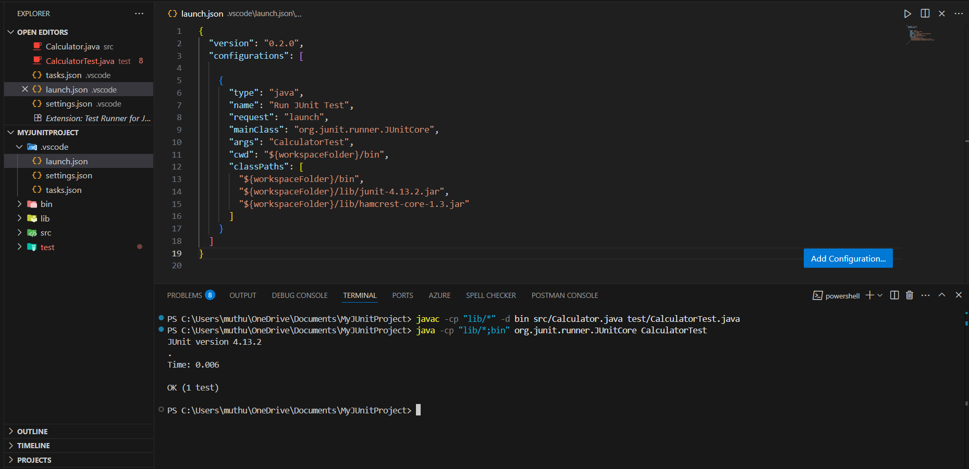

Assertions in Junit:

AssertionsTest.java

import org.junit.Test;
import static org.junit.Assert.*;

public class AssertionsTest {
@Test
public void testAssertions() {
assertEquals(5, 2 + 3);
assertTrue(5 > 3);
assertFalse(5 < 3);
assertNull(null);
assertNotNull(new Object());
}
}

Output:

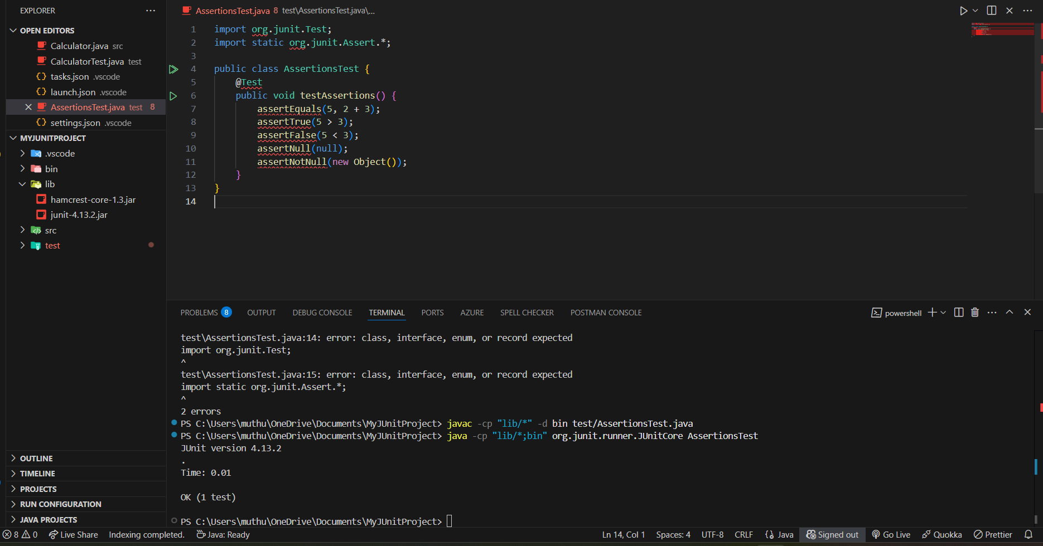

3. Mockito exercises:

Mocking and Stubbing:
src/ExternalApi.java:
public interface ExternalApi {
String getData();
}
src/MyService.java
public class MyService {
private final ExternalApi api;
public MyService(ExternalApi api) { this.api = api; }
public String fetchData() { return api.getData(); }
}
test/MyServiceTest.java
import org.junit.jupiter.api.Test;
import static org.junit.jupiter.api.Assertions.*;
import static org.mockito.Mockito.*;
import org.mockito.Mockito;

public class MyServiceTest {
@Test
void testExternalApi() {
ExternalApi mockApi = Mockito.mock(ExternalApi.class);
when(mockApi.getData()).thenReturn("Mock Data");
MyService service = new MyService(mockApi);
String result = service.fetchData();
assertEquals("Mock Data", result);
}
}
Output:
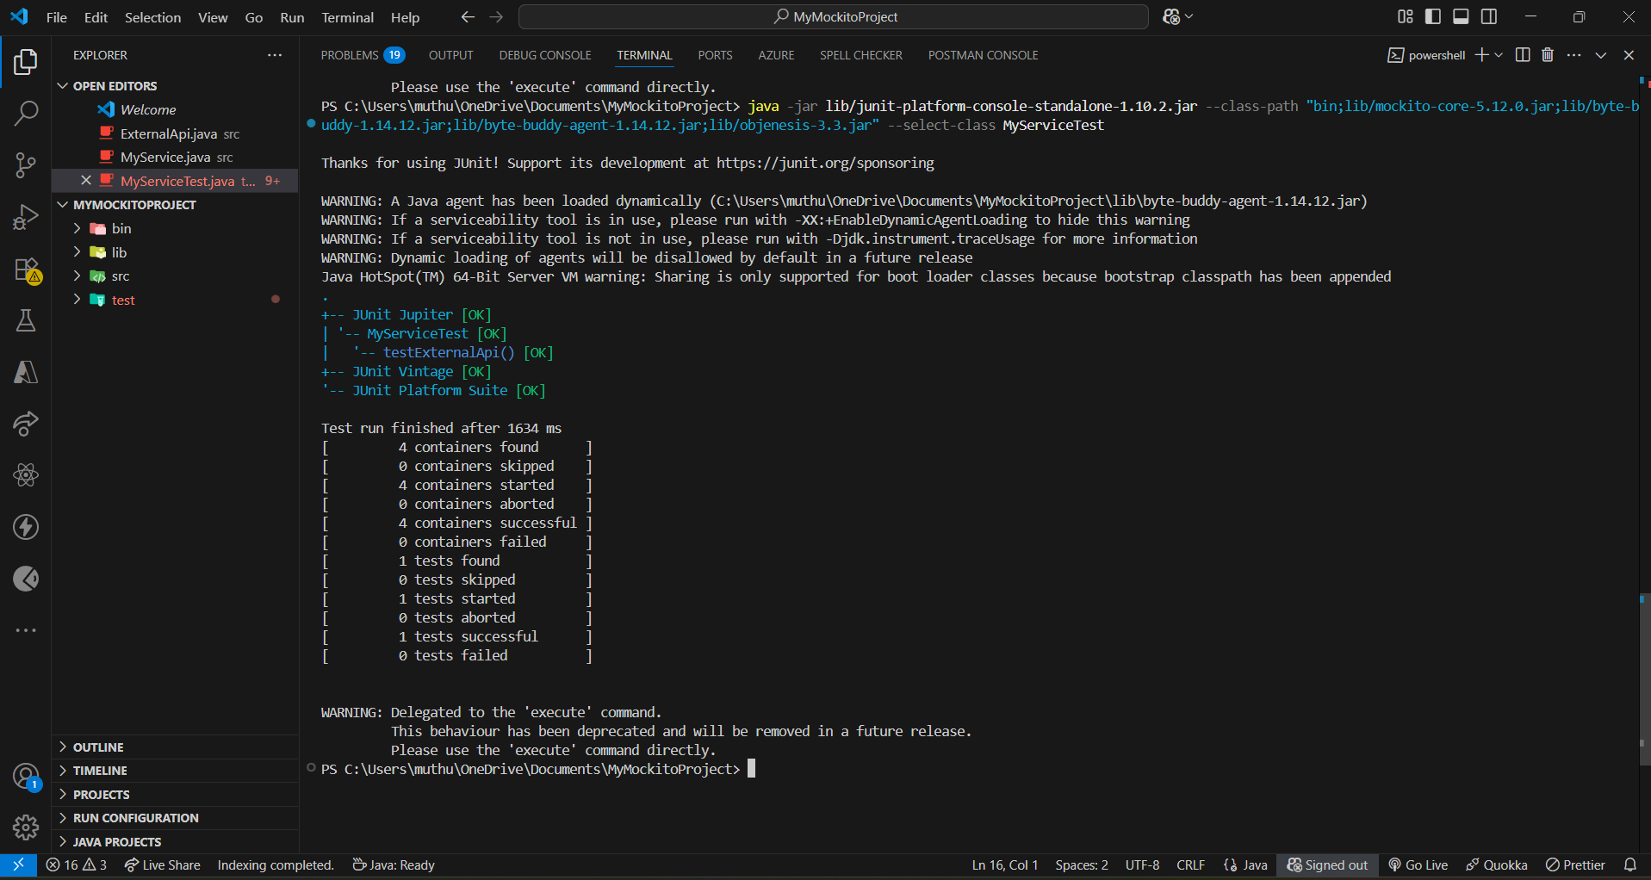
Verifying Interactions:
MyServiceTest.java
import static org.mockito.Mockito.*;
import org.junit.jupiter.api.Test;
import org.mockito.Mockito;

public class MyServiceTest {
@Test
public void testVerifyInteraction() {
ExternalApi mockApi = Mockito.mock(ExternalApi.class);
MyService service = new MyService(mockApi);
service.fetchData();
verify(mockApi).getData();
}
}
Output:
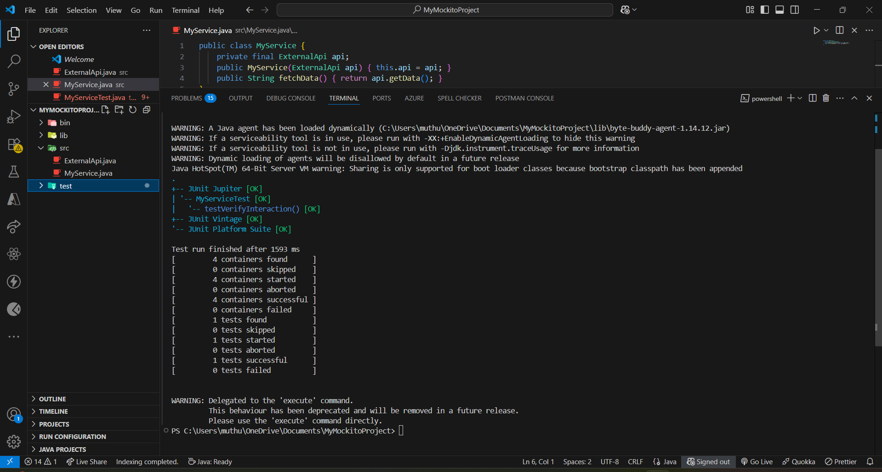

4. SL4J Logging exercises:

Logging Error Messages and Warning Levels:

LoggingExample.java

import org.slf4j.Logger;
import org.slf4j.LoggerFactory;

public class LoggingExample {
private static final Logger logger = LoggerFactory.getLogger(LoggingExample.class);

public static void main(String[] args) {
logger.error("This is an error message");
logger.warn("This is a warning message");
}
}

In lib/ folder:
• slf4j-api-1.7.30.jar
• logback-classic-1.2.3.jar
• logback-core-1.2.3.jar
Output:
